**Synthesis and structural characterization of thin Ga2S3 layers on semiconducting GaP substrate**

Cezariusz Jastrzebski1*, Daniel J. Jastrzebski2, Vitali Kozak1, Karolina Pietak2, Wojciech Gebicki1

(1) Faculty of Physics, Warsaw University of Technology; Koszykowa 75, 00-662 Warsaw, Poland

(2) Faculty of Chemistry, Warsaw University of Technology; Noakowskiego 3, 00-664 Warsaw, Poland

* corresponding author

**Abstract**

Ga2S3 crystal belongs to wide band gap materials with high transparency in visible and IR region. Additionally, it has a very high laser-induced damage threshold and high efficiency of second-harmonic generation. The last interest of Ga2S3 material is focused on surface passivation of different semiconductors to enhance their electrical and optical properties. This work concerns the growth of thin layers of gallium sulfides on semiconducting GaP substrates. Thin layers of Ga2S3 were obtained by reaction of sulfur vapor with thin plates of the semiconductor. AFM studies showed the topography of the obtained Ga2S3 layers. Their thickness ranged from several dozen nanometers to about 1-2 micrometers. The synthetized layers were structurally characterized by SEM and Raman spectroscopy. The obtained layers were identified as a monoclinic α'-Ga2S3 phase. Same area of cubic structure of Ga2S3 was also observed.

***Keywords***: Gallium (III) sulfide, Ga2S3 layers, wide bandgap semiconductors, Raman polarization measurements.

**Introduction**

*Properties and Applications*

Gallium chalcogenides are extensively studied in recent years. The different valence of gallium means that we deal with different crystal structures of gallium sulphides. The most known are gallium (II) sulfide - GaS and gallium (III) sulfide - Ga2S3. GaS sulphide is an interesting semiconductor with a layer structure [1]. The gallium (II) sulfide crystalize in b-GaS structure and has an indirect energy gap (2.53 eV) [2]. In addition, it is highly resistance to external conditions, is not soluble in water, has good mechanical properties and can be easily exfoliated to single atomic layers [3], [4].

Ga2S3 is much less explored. Quite commonly known and studied is a glassy form of Ga2S3, where the structure is in the form of GaS4 tetrahedra connected with each other in a rather loose manner. Ga2S3 based glasses are materials transparent in wide optical range, are chemically stable and are promising material for nonlinear optics. Chalcohalide glasses of Ga2S3 are promising material with third-order optical nonlinearity [5] and efficient photoinduced THG [6]. There is also interest in lanthanum gallium sulfide glasses which can be easily doped with other metals. These materials have excellent properties for optical lenses, optical amplifiers for telecommunications and for laser fabrication.

For decades there were different discrepancies regarding to the crystalline phase of Ga2S3. This is due to the mismatch of valence electron numbers and in consequence a variety of structures with different stoichiometry and crystalline phases are observed.

Currently, four main crystalline phases can be identified [7]:

1. A white colored low-temperature α-Ga2S3 phase modification. It crystallizes in a cubic defect type sphalerite lattice F-43m. Lattice constant a=5.181 A. Chemical formula Ga2.67S4 [12].
2. A light yellow β-modification, i.e. β-Ga2S3. It crystallizes in the hexagonal disordered defect (wurtzite-type structure) lattice P63mc. Lattice parameters a = 3.685 A, c=6.028 A.
3. An orange-yellow α'-modification crystallizes in the monoclinic lattice, space group C1c1 (No.9). Lattice parameters a=11.107, b=6.395, c=7.021 Å, β= 121.17 ° [8]. The structure can be described as a distorted wurtzite form. The elementary cell of Ga2S3 crystal comprise four molecules. The sulfur atoms are nearly hexagonally close-packed in layers perpendicular to the c axis . Modification with Bb space group is observed. Lattice parameters a=11.094, b=9.578, c=6.395 Å, β= 141.15 °
4. high temperature hexagonal (wurtzite type) -modification (-Ga2S3) with the space group P61 and P65. Lattice parameters for space group P61 a = 6.385 A, c=18.040 A.

There is mismatch in the published data on naming of different phases by Greek symbols (, ’,  and ). It happens that the phases  and  are used interchangeably in the literature [10].

The GaS4 tetrahedra are the most important building blocks in all their structures. This is due to the fact, that the Ga2S3 is a naturally defect semiconductor with one-third of Ga vacancies, ordered in different way [15]. The different ordering in the cation sublattice results in the polymorphism [9]. Sulfur atoms are arranged almost perfect in close packed hexagonal lattice. The lattice structures of all the phases are similar. Only small changes between different phases are observed. For all the structures of Ga2S3, the main XRD peak positions are nearly the same. The significant difference is visible only in their relative intensity in these phases.

The monoclinic Cc phase is the most standardized form. It is also the most common and stable phase.

Fig.1. Crystal structure of a monoclinic phase of Ga2S3

Among the many advantages of Ga2S3, it should be emphasized that it is a non-toxic, environmentally friendly material with reasonable chemical stability.

As in the case of crystalline structures, there are discrepancies in the literature about the basic properties of these structures. Ga2S3 is the direct energy gap material. In some works the value of the energy gap for monoclinic phase is given as 3.4 eV [8] [12] and in others as 3.05 eV [9] [7]. For different phases, values of band gaps ranging from 2.5 to 3.4 eV can be found in the literature. Also, the calculations from the first principles lead to results that differ significantly from the experimental values [12].

The crystalline GaS structures exhibit very high sensitivity in the blue and ultraviolet regions. Thus the Ga2S3 reveal as a highly-sensitive photoconductive material for blue to ultraviolet (UV) photodetectors [7] [8]. Photosensitivity of Ga2S3 crystals can be additionally enhanced in selective regions by dopands. For example, the maximum photosensitivity band of the compounds based on Ga2S3 crystal is 3.45 eV and for Ga2S3:Cd photo resistor is 3.60 eV [12].

Presence of many vacancies in Ga sub lattice result consequently in defect photoemission. Observed strong PL from structures of Ga2S3 has a maximum around 1.6 eV and spreads up to 3.0 eV (blue-green luminescence at room temperature) [14]. Doping with Fe, transition-metal or rear-earth element, strong luminescence response is observed over the all visible range [13]. Additionally, the luminescence can be amplified in different regions by doping [19].

It was observed that Ga2S3 has a large second harmonic generation efficiency (SHG), high laser induced damage threshold, wideband spectral transparency especially in the IR region [21], [22].

The transparency range spreads in the near IR range from 0.44 up to 25 mikrom and also in THz range- spectral range in the THz range at wavenumbers below 100 cm _1 doesn’t shows phonon absorption peaks. Thus the crystalline Ga2S3 shows as prospective materials for THz applications [8].

Despite this, Ga2S3 has been investigated for light-emitting diodes and photovoltaic devices while recently, it was shown that Ga2S3 has a large second harmonic generation efficiency ideally suited for nonlinear optics [9]. The β-Ga2O3/Ga2S3 NWs may be used in various applications including sensors, non-toxic biomedical imaging, and energy down-conversion in nanowire solar cells [12].

Numerical calculations from the first principles also show interesting properties both in terms of non-linear properties as to the generation of 2 harmonics as well as piezoelectric properties in the case of thin Ga2S3 layers [9].

The thin layers of Ga2S3 on III-V semiconductor materials are used for surface passivation. However, due to the special properties of Ga2S3, the optical performance in these materials can be improved in such cases [24].

Despite many distinctive and interesting properties of Ga2S3, the main obstacle to wider applications is the lack of developed technological processes allowing to obtain high quality Ga2S3 materials with controlled stoichiometry and specified crystalline structure.

**Raman spectra of Ga2S3**

Ogólnie

Raman spectroscopy is widely used to characterize Ga2S3 glasses and crystal phases [7] [8] [9]. The structure of monoclinic Ga2S3is close to a defective wurtzite structure. The strongest scattering lines are observed in the range of 100–450 cm−1

O podziale na dwa obszary

Most of the frequencies can be assigned in terms of internal and external vibrations of tetrahedral GaS4groups

1 obszar

Raman spectra for the -Ga2S3, shows very sharp bands at 119, 135 and 148 cm-1 due to Ga-S2 scissoring.

The sharp bands at 119, 135 and 148 cm-1 are mainly due to the Ga-S2 scissoring [16] and

the band at 238 cm-1 is due to the ring out plane bending of (-Ga2S3).

2 obszar

There are seven peak features at 234, 282, 309, 331, 348, 387, and 427 cm-1 detected in the Ga2S3 crystal Ga2S3 in the energy range of 200–500 cm−1. Most of the frequencies can be assigned in terms of internal and external

vibrations of tetrahedral GaS4 groups (see SI)21,22 [15]. The symmetricGaS4molecule has four fundamental vibration modes expressed by  = A1+ E + F1+ F2[29]. The assignments of the Raman modes is as follows [lit]: s-GaS4 (234 cm-1, A1),

For the Raman scattering of the monoclinic Ga2S3, the dominant peaksare located at 234 and 387 cm−1(see Fig. 3(a)), which can be pri-marily associated with the _1(A1) and _4(F2) modes [29] of the GaS4 molecular unit.

The presence of Ga-S symmetric stretching is clearly identified with the large intense spectral band at 392.4 cm-1[12].

The Raman peak for Ga2S3 reveal relative narrowed line widths. It indicates that the as-grown Ga2S3 crystals possess usually high crystallinity and ( for example in the monoclinic phase).

Raman spectra of the Ga2S3 nicro crystals is presented in Fig 3

[28,29].



The lower part of Fig. 3(b) shows observed in Fig. 3(a), and their association with vibrations of the GaS4molecules in the upper part in Fig. 3(b). (like _-In2Se3[30]) and which exhibits tetrahedral bonding with one-third Ga sites (on the average) are vacant tend to broaden the line widths of the Raman peak features.

[29] C. Julien, S. Barnier, I. Ivanov, M. Guittard, M.P. Pardo, A. Chilouet, Vibrationalstudies of copper thiogallate solid solutions, Mater. Sci. Eng. B 57 (1999)102–109.

The relative weights of Ge and Ga suggest that two of the frequencies of normal vibrational mode of [GaS4] can be expected in the vicinity of those of [GeS4] tetrahedraand was proposed to be located at 350 cm-1ν1(A1) and 390 cm-1ν3(F2) or νc1(A1) [36]. Ishibashi et al. [57] measured low resolution spectra of RS-Ga2S3glasses (R =Ca, Sr, Ba) and proposed a different assignment based on analysis of α-Ga2S3,SrGa2S4and BaGa2S4crystals. The main peak at 233 cm-1of α-Ga2S3 phase is in good agreement with our spectrum peaking at 237 cm-1and 390 cm-1. In α-Ga2S3 the[GaS4] tetrahedra are linked by corners and S atoms present two-fold and three-fold coordination and the main peak is attributed to the stretching vibration of [GaS4] tetrahedra (s [GaS4](A1); vibrations of the sulfur anions) and 390 cm-1 to the deformationvibration(d [GaS4](F2)) [58]. The SrGa2S4crystal with [GaS4] corner and edge sharing tetrahedra presents two main peaks at 280 and 357 cm-1related to svibration modes of two [GaS4] tetrahedraconnected by edge and d(Ga-S-Ga) of [GaS4] connected by corners, respectively. The BaGa2S4 crystalis a 3D framework with only corner sharing [GaS4] tetrahedra and the 303 cm-1 peakis attributed to d[GaS4] (F2) deformation mode. Based on their assignments for these reference crystals, they associated for RS-Ga2S3glasses a band at 318 cm-1 to the d[GaS4] (F2) or s[GaS4]edge-sharing and 358-378 cm-1 to (Ga-S-Ga) deformation mode of [GaS4]corners sharing.





Troche niepokojące, bo sugeruje, że widmo dla kubicznej I monoclinic niewiele się różni

For monoclinic samples. From spectra (a) and (b) it may be concluded that difference in melt cooling rate does not lead to principal changes in the Raman peaks. So, a broadening of major peak at 250 cm _1 and appearance of intensive peak at _290 cm _1 may indicate the presence of cubic phase in the sample. However, in one of the previous studies of Ga2S3 it was affirmed that Raman spectra of different modifications are indistinguishable due to the likeness of crystal structure [8].

To dosyć ważne stwierdzenia na podst [7] a dotyczy poniżej

The structure of Ga2S3 is composed of GaS4 tetrahedra. By Lucazeau and Lorey [12] the Raman

lines may be interpreted as stretching modes of the tetrahedra at frequencies above 270 cm–1, while

frequencies below 200 cm–1 can be assigned to its bending modes. Some lines may correspond to

external vibrations: rotational and translational modes in the molecular substructure of GaS4. The

strongest line, located at ~250 cm–1 is likely to be the А1 mode of the GaS4 groups: vibrations of the

sulfur anions around vacancies in the anion–vacancy direction.

It should to be noted that because of the small distortion in lattice structures of Ga2S3

polymorphs, it is very difficult to identify the polymorph type with Raman spectroscopy.

**Experimental details**

For Raman measurement,a Renishaw micro-Raman spectrometer equipped with a 514-nmAr+ ion laser was used for the structural characterization of theM2S3materials. The laser spot size (diameter) was reduced to∼5 _m and laser power was adjusted to ∼2 mW.

**Results and discussion**

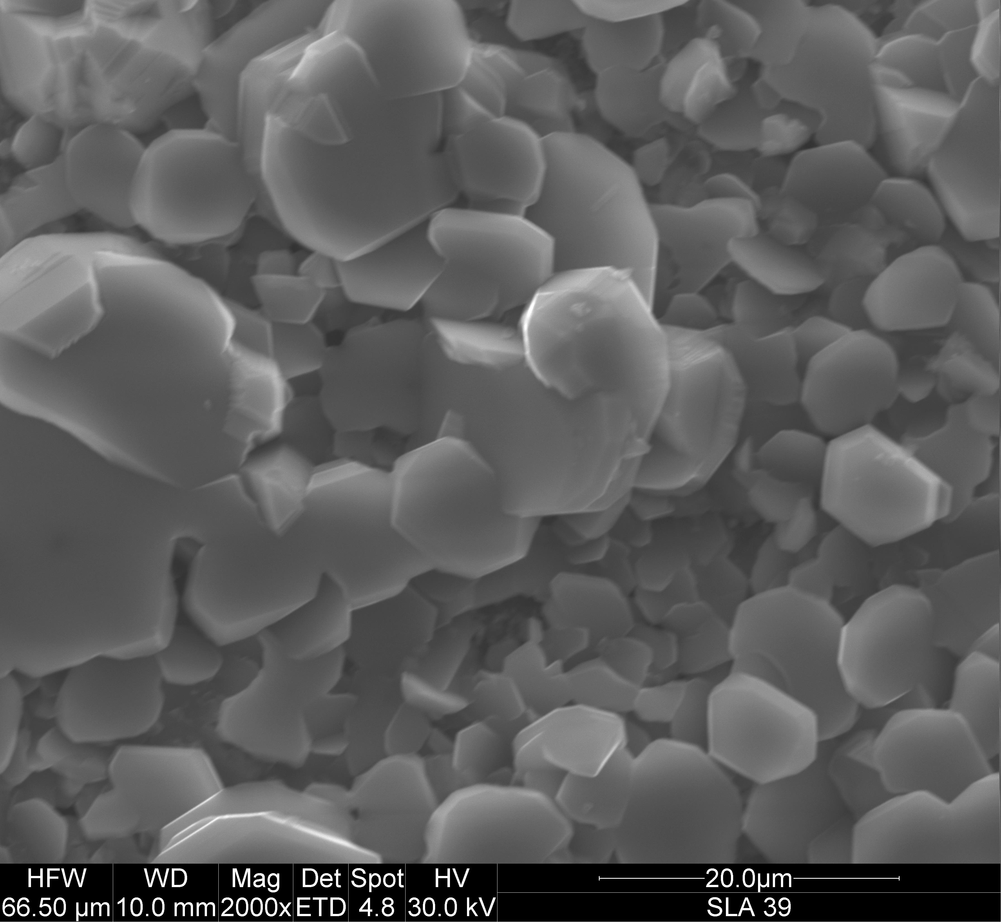 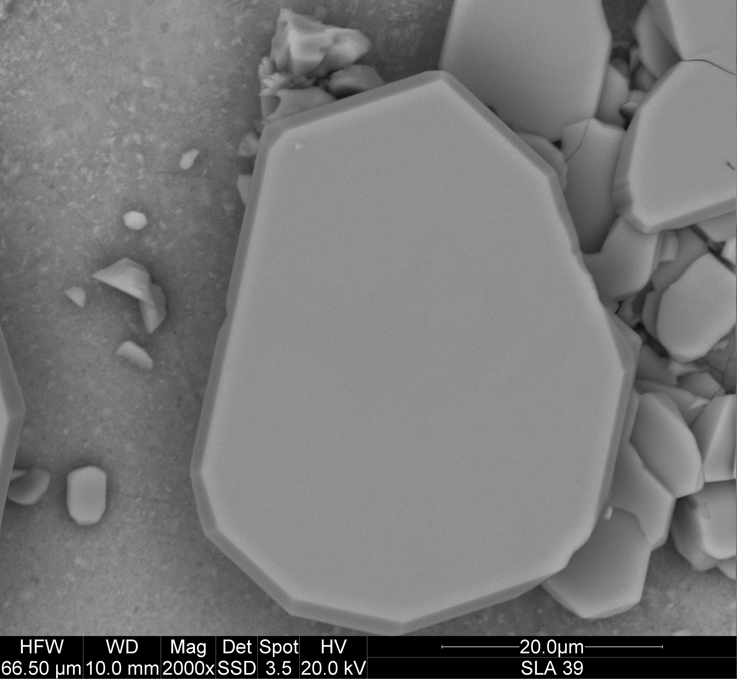

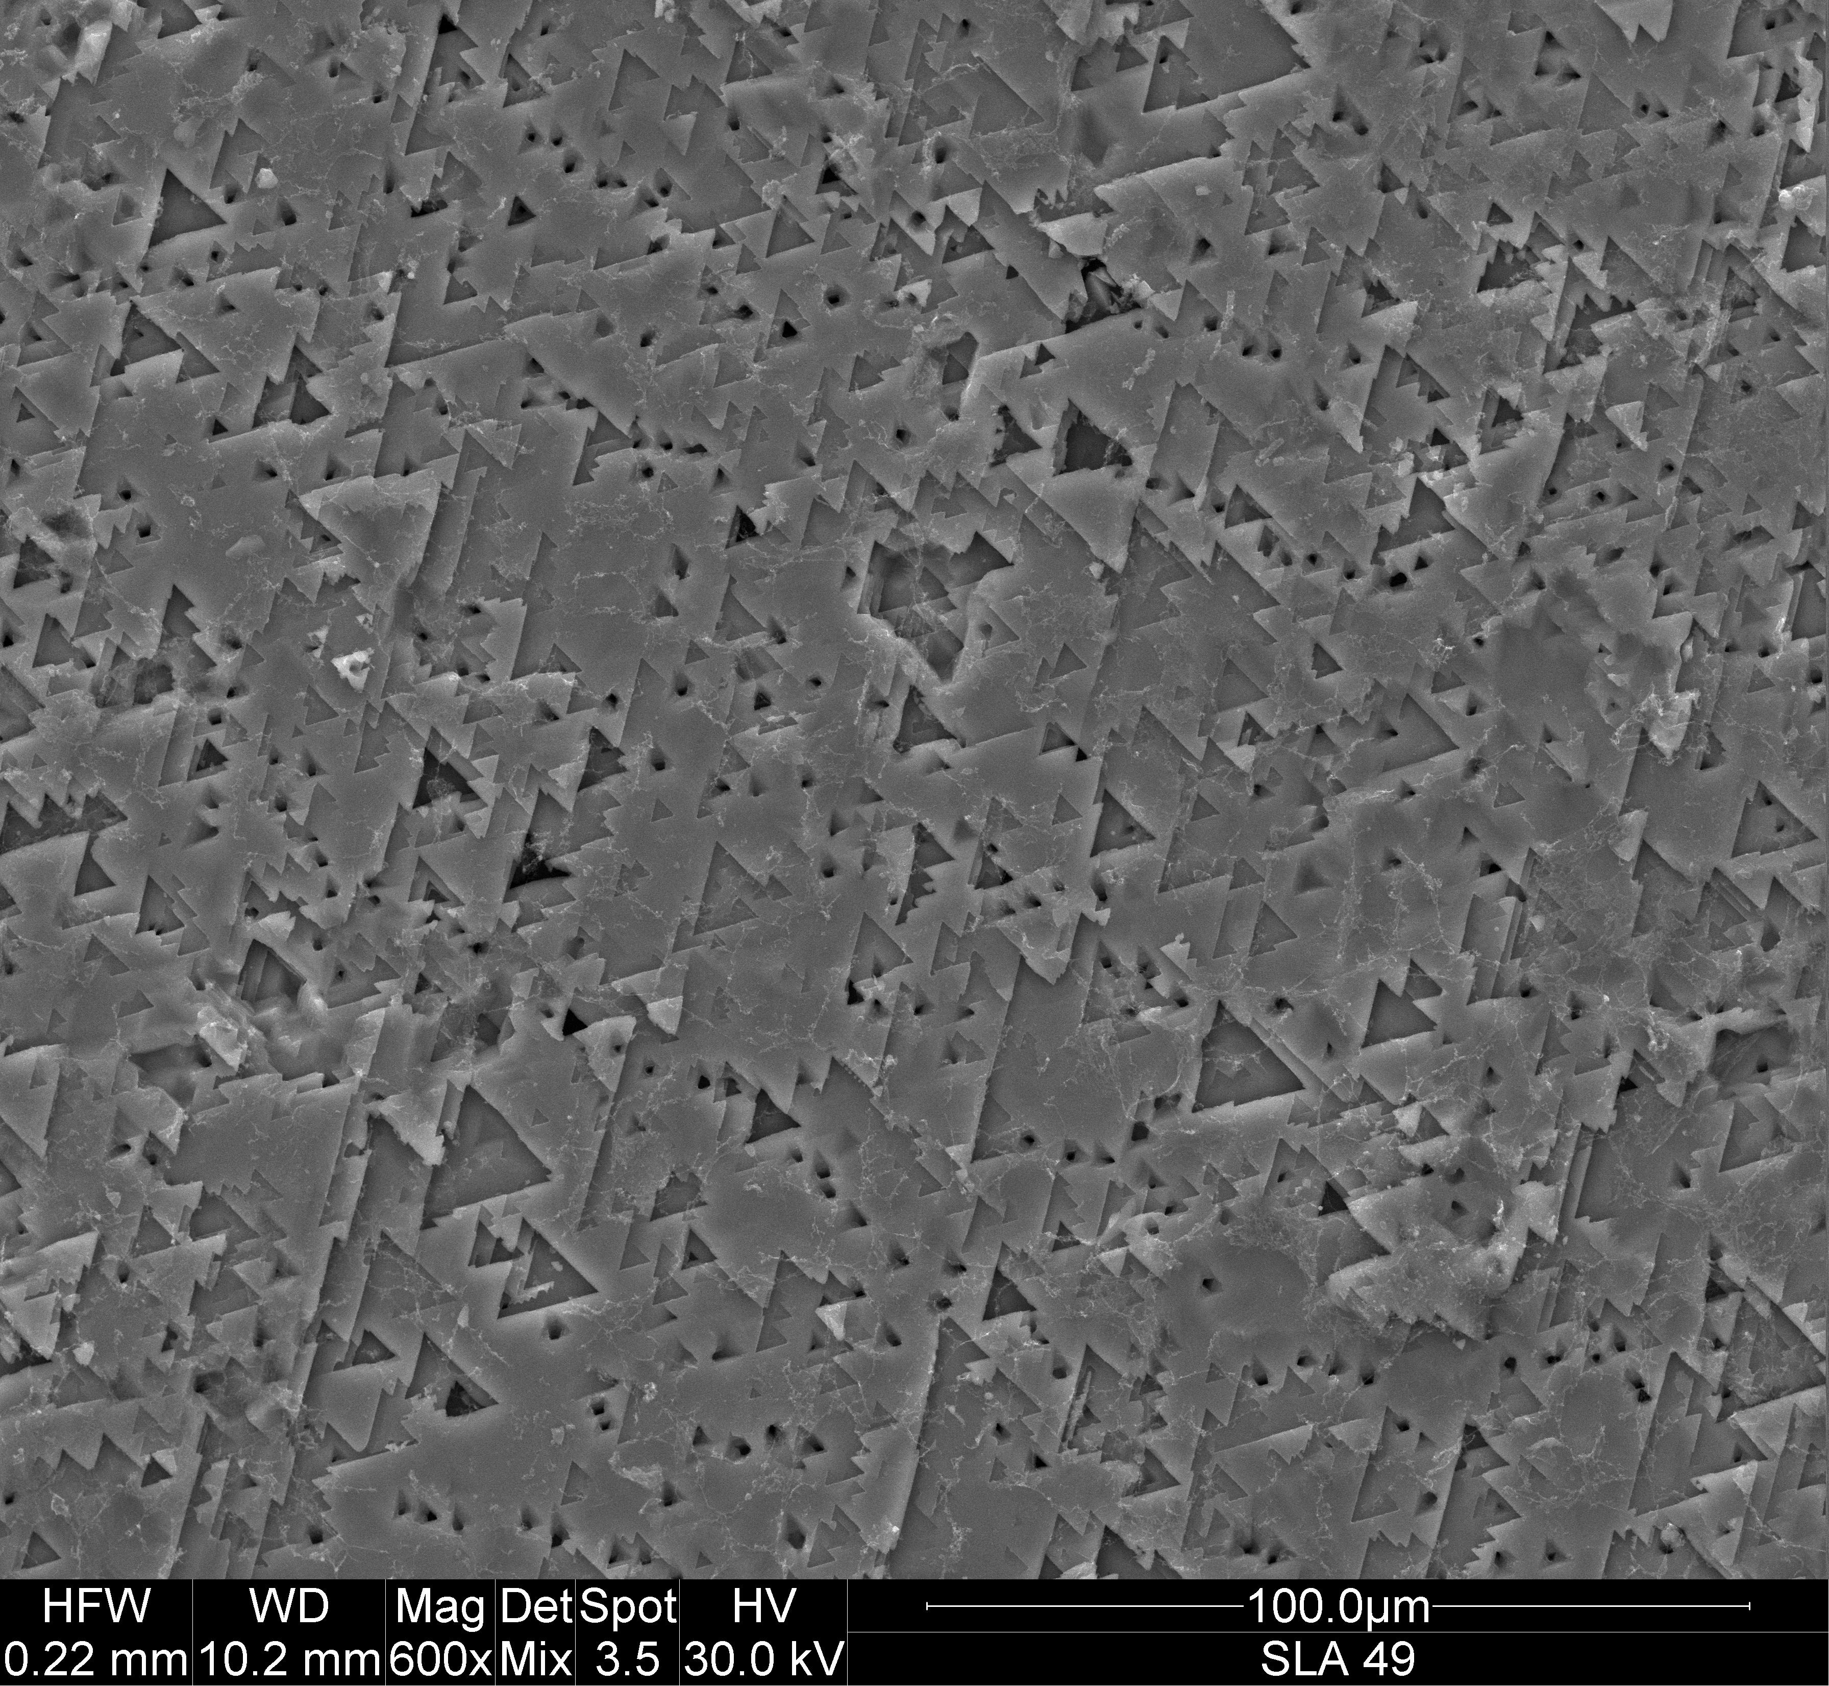

Fig. 2. Morphology of GaP surface with deposited thin layer of gallium sulfide. SEM image …

Structural investigation of Ga2S3 films based on Raman spectroscopy.

Raman scattering spectroscopy can provide information about the vibration modes characteristic in crystal phase and crystalline states of the probed crystals. The vibration frequencies and linewidths of the Raman modes are affected by local atomic arrangement including relative atomic oscillation, defects and structural disorder.

The crystal morphology and crystal color of the Ga2S3sample are also displayed in the inset of Fig. 1(b) for comparison.

The monoclinic symmetry of the as-grown Ga2S3is confirmed by comparing the data with previous XRD result

The Raman result in Fig. 2 approximately verifies thatthe as-grown In2S3are _ phase crystals, which exhibit a little bit amorphous and defect-contained state.

**Conclusions**

**Literature**

[i04] Liu HF, Antwi KKA, Yakovlev NL, Tan HR, Ong LT, Chua SJ, Chi DZ. Synthesis and Phase Evolutions in Layered Structure of Ga2S3 Semiconductor Thin Films on Epiready GaAs (111) Substrates ACS. Appl Mater Interfaces 2014;6:3501-07.

[i08] L. Bai, Z. S. Lin, Z. Z. Wang and C. T. Chen, J. Appl. Phys., 2008, 103, 083111.

[i09] L. Bai, Z. S. Lin, Z. Z. Wang, C. T. Chen and M. H. Lee, J. Chem. Phys., 2004, 120, 8772–8778.

[i10] H. Hahn and G. Frank, Z. Anorg. Allg. Chem., 1955, 278, 333–339.

[i11] J. Goodyear and G. A. Steigmann, Acta Crystallogr., 1963, 16, 946–949.

[rs03] X.F. Wang, S.X. Gu, J.G. Yu, X.J. Zhao, Solid State Commun. **130**, 459 (2004).

|  |  |
| --- | --- |
| [1] | †. C. B. Z. G. D. H. D. M. Andrew Harvey, "Preparation of Gallium Sulfide Nanosheets by Liquid Exfoliation and," *Chem. Mater.,* pp. 3483−3493, DOI: 10.1021/acs.chemmater.5b00910, 2015. |
| [2] | C. H. H. a. S. L. Lin, "Optical properties of the interband transitions of layered gallium sulfide," *Journal of Applied Physics,* p. http://dx.doi.org/10.1063/1.2358192, 2006. |
| [3] | B. L. ,. H. S. S. R. M. ,. C. N. R. R. ,. Dattatray J. Late, "Rapid Characterization of Ultrathin Layers of Chalcogenides," *Adv. Funct. Mater,* p. 1894–1905, 2012. |
| [4] | C. J. [. ,. S. P. [. ,. D. J. [. ,. R. G. ✓. [. ,. W. G. [. ,. P. W. [. ,. K. W. Maciej Białogłowski [1], "Synthesis of tin disulfide single crystals for nano-layer exfoliation," *CRYSTAL RESEARCH AND TECHNOLOGY,* pp. 695-699, http://dx.doi.org/10.1002/crat.201400436. |
| [5] | H. T. F. C. H. G. C. L. X. Z. X. ZHENG, *Chalcogenide Letters, Vol. 8, No. 6,,* p. 371 – 376, 2011. |
| [6] | L. V. P. O. V. P. L. P. M. I. D. O. O. V. Tsisar, *J Mater Sci: Mater Electron,* pp. 19003–19009, DOI 10.1007/s10854-017-7854-x, 2017, 28. |
| [7] | 2. L. I. S. V. G. P. B. A. A. Y. KOKH Konstantin1, "Synthesis and Bridgman Growth of Ga2S3 Crystals," *Key Engineering Materials,* pp. 71-76, DOI: 10.4028/www.scientific.net/KEM.683.71, 2016. |
| [8] | X.-M. J. L.-J. Z. a. G.-C. G. Ming-Jian Zhang, "Two phases of Ga2S3: promising infrared second-order nonlinear optical materials with very high laser induced damage thresholds," *J. Mater. Chem. C, 1,,* pp. 4754, DOI: 10.1039/c3tc30808a, 2013. |
| [9] | K. K. a. J. E. C.Y. Jones J.C. Bryan, "Refinement of the crystal structure of digallium trisulfide, Ga2S3," *Ζ. Kristallogr. NCS 216,* pp. 327-328, 2001. |
| [10] | C. e. a. Julien, " Vibrational studies of copper thiogallate solid solutions.," *Mater. Sci. Eng. B57,* p. 102–109, 1999. |
| [11] | L. I. P. a. V. .. .. C. V . P. MUSHJNSKII, "Optical Absorption inw-Ga S Single Crystals," *phys. stat. sol. (b) -83,* p. 149, 1977. |
| [12] | C. H.-H. Ho C-H, "Optically decomposed near-band-edge structure and excitonic transitions in Ga2S3.," *Scientific Report;4,* pp. 6143-51, 2014. |
| [13] | b. M.-H. L. Y.-P. W. Y.-S. H. Ching-Hwa Hoa, "Synthesis of In2S3and Ga2S3crystals for oxygen sensing and UV photodetection," *Sensors and Actuators A: Physical 245,* p. 119–126, 2016. |
| [14] | b. M.-H. L. Y.-P. W. Y.-S. H. Ching-Hwa Hoa, "Synthesis of In2S3and Ga2S3crystals for oxygen sensing and UV," *Sensors and Actuators A: Physical A 245,* p. 119–126, 2016. |
| [15] | D. R. E. A. I. I. CARAMANa*, "THE DETECTORS OF UV AND X RADIATION BASED ON Ga2S3 AND GaSe SEMICONDUCTORS INTERCALATED WITH Cd," *Journal of Optoelectronics and Biomedical Materials, Vol. 7,* pp. 27 - 32, 2015. |
| [16] | K. A. e. a. H. Liu, *ACS Appl. Mater. Interfaces 6,,* p. 3501, 2014. |
| [17] | F. M. L. M. T. P. M. J. W. K. C.S. Yoon, "Blue photoluminescence of a-Ga2S3 and a-Ga2S3: Fe2+ single crystals,," *Appl. Phys. Lett. 83,* p. 1947, 2003. |
| [18] | F. D. M. L. M. T.-Y. P. M.-S. J. a. W.-T. K. Chang-Sun Yoon, "Blue photoluminescence of and single crystals," *Appl. Phys. Lett. 83,,* p. 1947; doi: 10.1063/1.1609254, 2003. |
| [19] | D. N. Nikogosyan, Nonlinear optical crystals: a complete survey,, New York: Springer, 2005.. |
| [20] | S.-P. G. H.-Y. Z. M.-J. Z. a. G.-C. G. X.-M. Jiang, *Struct. Bonding, 145,* p. 1–44., 2012. |
| [21] | b. Z.-M. H. J.-G. H. Y.-Q. G. B. U. J. P. I. L. V. S. G. L. Y. M. A. K.A. Kokha, "Study of Ga2S3 crystals grown from melt and PbCl2 flux," *Materials Research Bulletin 84, ,* p. 462–467, 2016. |
| [22] | A. K. Y. N. T. H. O. L. C. S. C. D. Liu HF, "Synthesis and Phase Evolutions in Layered Structure of Ga2S3 Semiconductor Thin Films on Epiready GaAs (111) Substrates," *ACS. Appl Mater Interfaces,* pp. 3501-07., 2014;6:. |
| [23] | 3. M. Z. C. C. a. A. O. Katerina M Othonos1, "Ultrafast Spectroscopy and Red Emission from β-Ga2O3/β-Ga2S3 Nanowires," *Nanoscale Research Letters 10,* pp. 304, DOI 10.1186/s11671-015-1016-y, 2015. |
| [24] | E. A. Plis, M. N. Kutty and S. Krishna, *Laser Photonics Rev.7,* pp. 45-59., 2013. |
| [25] | T. A. a. S. M. Alshehri, "Green Synthesis and Characterization of Gallium(III) Sulphide (α-Ga2S3) Nanoparicles at Room Temperature," *Nano Hybrids Vol. 6,* pp. 37-46, doi:10.4028/www.scientific.net/NH.6.37, 2014. |
| [26] | *. V. N. ,. V. N. V. N. ,. V. N. V. N. ,. V. N. b. R. C. ,. R. C. ,. R. C. R. C. R. C. R. C. R. C. b. B. B. ,. B. B. ,. B. B. ,. B. B. b. I. I. Pethes I. Pethes I. PethesI. Pethes a, "Local motifs in GeS2-Ga2S3 glasses". |
| [27] | "GeS2–Ga2S3–LiCl Glass System: Electrical Conductivity," *International Journal of Applied Glass Science,* pp. 513–523, DOI:10.1111/ijag.12189, 2016. |
| [28] | Y. T. a. S. L. b. A. Tverjanovich a3*, "Raman spectra of gallium sulfide based glasses," *Journal of Non-Crystalline Solids 208,* pp. 49-55, 1996. |
| [29] | C. H.-H. Ho C-H, "Optically decomposed near-band-edge structure and excitonic transitions in Ga2S3," *Scientific Report.4:61.,* pp. 43-51, 2014. |
| [30] | L. H. *. a. X. Huang, "Peculiar electronic, strong in-plane and out-of o fplane second harmonic generation and piezoelectric properties of atom-thick a-M2X3 (M =Ga, In; X ¼ S, Se): role of spontaneous electric dipole orientations," *RSC Adv., 7,,* pp. 55034–55043, DOI: 10.1039/c7ra11014f, 2017,. |